# Appendix B – High Fidelity Drawings

# Design 1

# C:\Users\home#\AppData\Local\Microsoft\Windows\INetCache\Content.Word\1frontpage.jpeg

# C:\Users\home#\AppData\Local\Microsoft\Windows\INetCache\Content.Word\2whatareDAs.jpegC:\Users\home#\AppData\Local\Microsoft\Windows\INetCache\Content.Word\3case studys.jpegC:\Users\home#\AppData\Local\Microsoft\Windows\INetCache\Content.Word\4industrys.jpegC:\Users\home#\AppData\Local\Microsoft\Windows\INetCache\Content.Word\contact.jpeg

## Design 2

# C:\Users\home#\AppData\Local\Microsoft\Windows\INetCache\Content.Word\onepage.jpeg

## Design 3

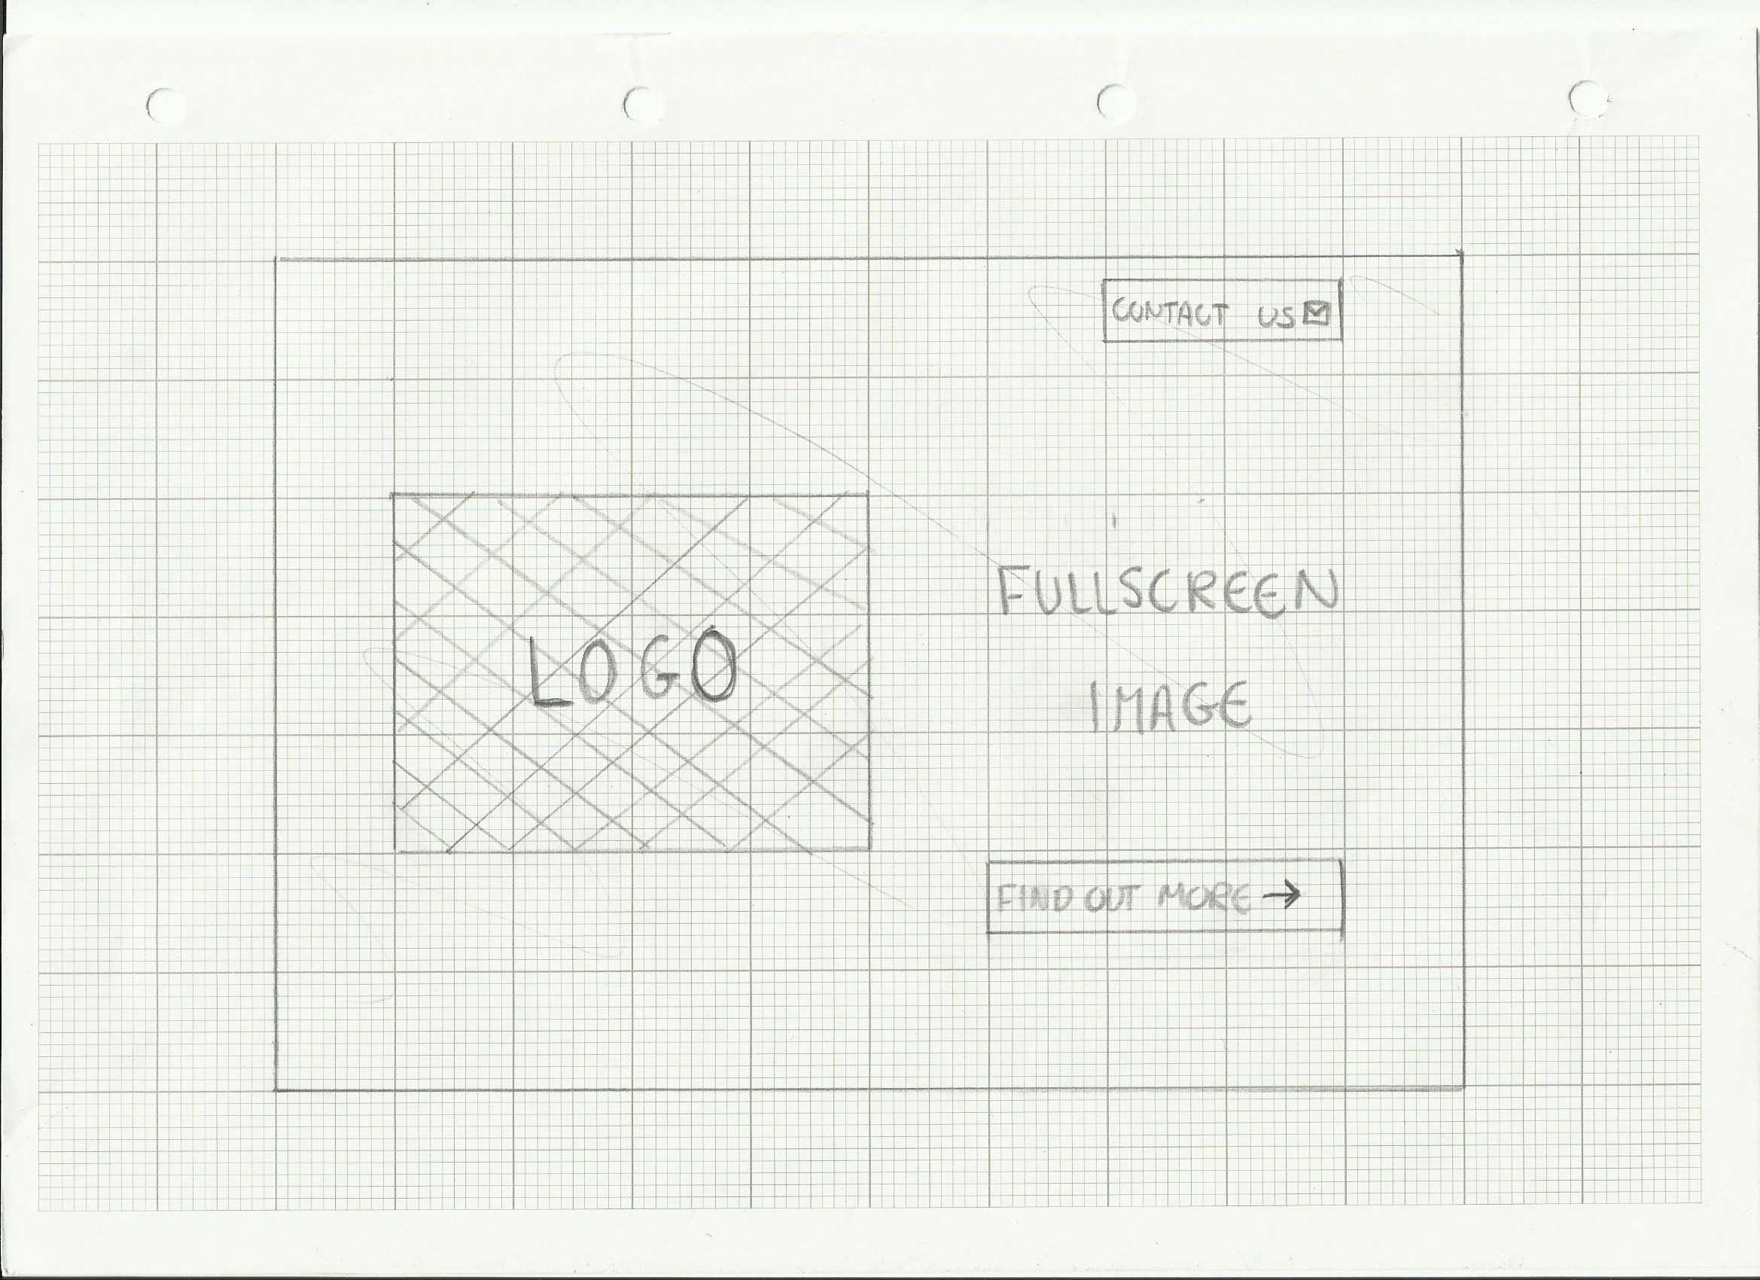

# 

## Appendix C – Paper Prototypes

## Paper Prototype 1

